Task 1
- Create a folder named sample and paste the docker-compose and php.docker file in it and along with src folder

Task 2
- Run the following command from within the folder to open VS Code
“code .”
Task 3
- Open VS code terminal and use the following command to start the docker
“sudo docker-compose up”

Task 4
- Create the following directory hierarchy with the help of VS code terminal

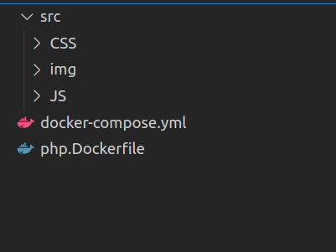

Task 5
- Create the following files with the help of VS Code terminal

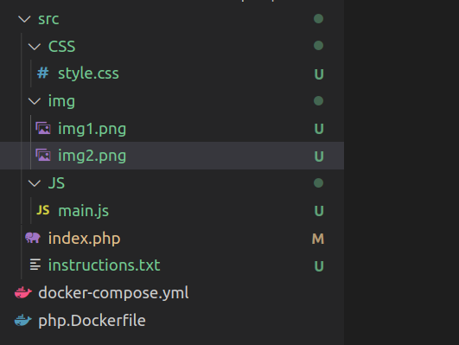

Task 6
- use the following command to stop container
“sudo docker-compose down”

Task 7
- Use the folowing command to remove conatiner
“sudo docker container rm -f $(sudo docker container ls -q -a)”

Task 8
- Use the folowing command to remove images
“sudo docker image rm -f $(sudo docker image ls -q -a)”

